Dashboards and Reports: Tracking Progress and Performance in Jira

1. Creating Personal and Team Dashboards in Jira
A Dashboard in Jira is a customizable visual workspace that displays real-time project data using gadgets. Dashboards help individuals, teams, and managers monitor progress at a glance.
Types of Dashboards
- Personal Dashboard – Focused on individual tasks and priorities
- Team Dashboard – Shared view for team progress and health

Hands-On Lab: Create a Dashboard
- Click Dashboards → Create dashboard
- Enter:
  - Name: Agile Project Dashboard
  - Description: Sprint & workflow tracking
- Choose visibility:
  - Private / Project / Public
- Click Create
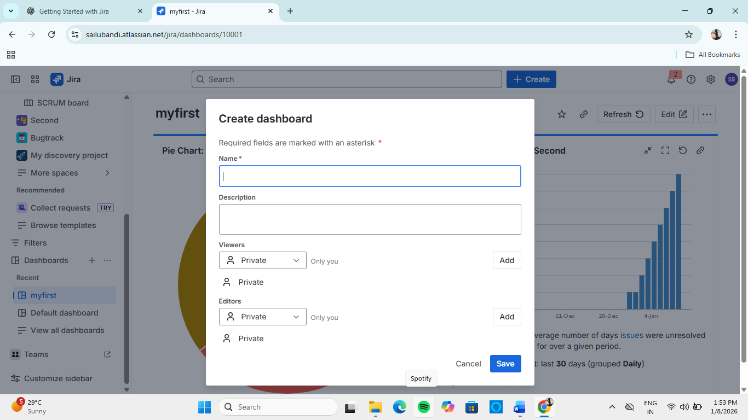

Why Dashboards Are Important
✔ Centralized visibility
✔ Real-time tracking
✔ Reduced manual reporting
✔ Better decision-making

2. Useful Gadgets for Your Jira Dashboard
Gadgets are small widgets that display specific information on dashboards.
Commonly Used Gadgets
Gadget | Purpose
Filter Results | List of issues from a saved filter
Pie Chart | Issue distribution by status/priority
Two-Dimensional Filter | Compare two fields
Sprint Burndown | Track sprint progress
Assigned to Me | Personal workload

Hands-On Lab: Add Gadgets
- Open dashboard
- Click Add gadget
- Select gadget (e.g., Filter Results)
- Choose saved filter
- Save configuration
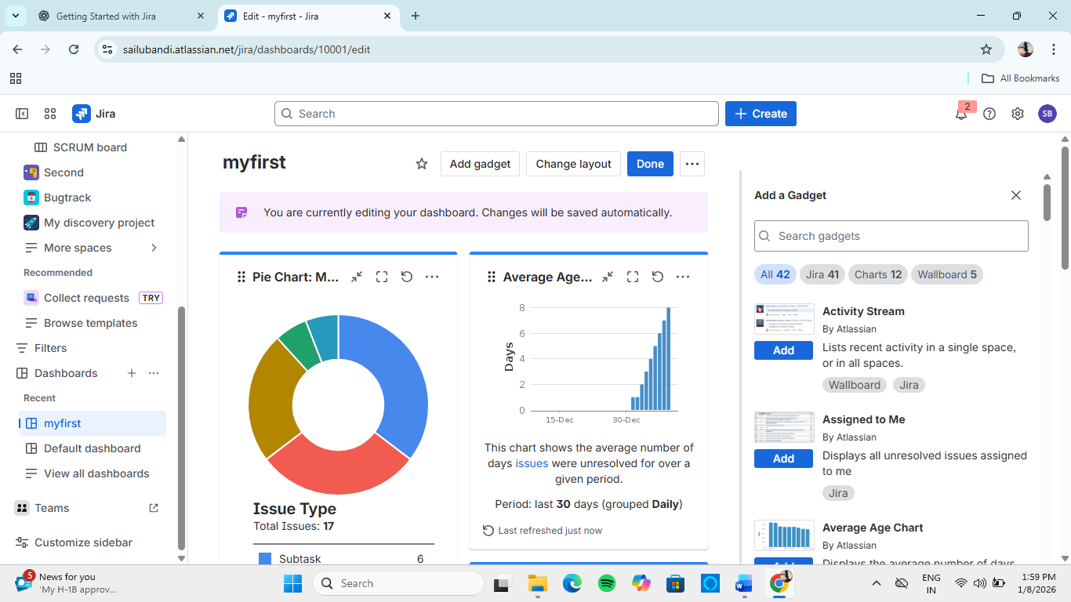

Professional Tip
Dashboards are most effective when they are simple, role-specific, and updated automatically.

3. Sharing and Cloning Dashboards
3.1 Sharing Dashboards
Dashboards can be shared with:
- Specific users
- Project roles
- Entire organization
Steps
- Open dashboard
- Click Share
- Select users or roles
- Save
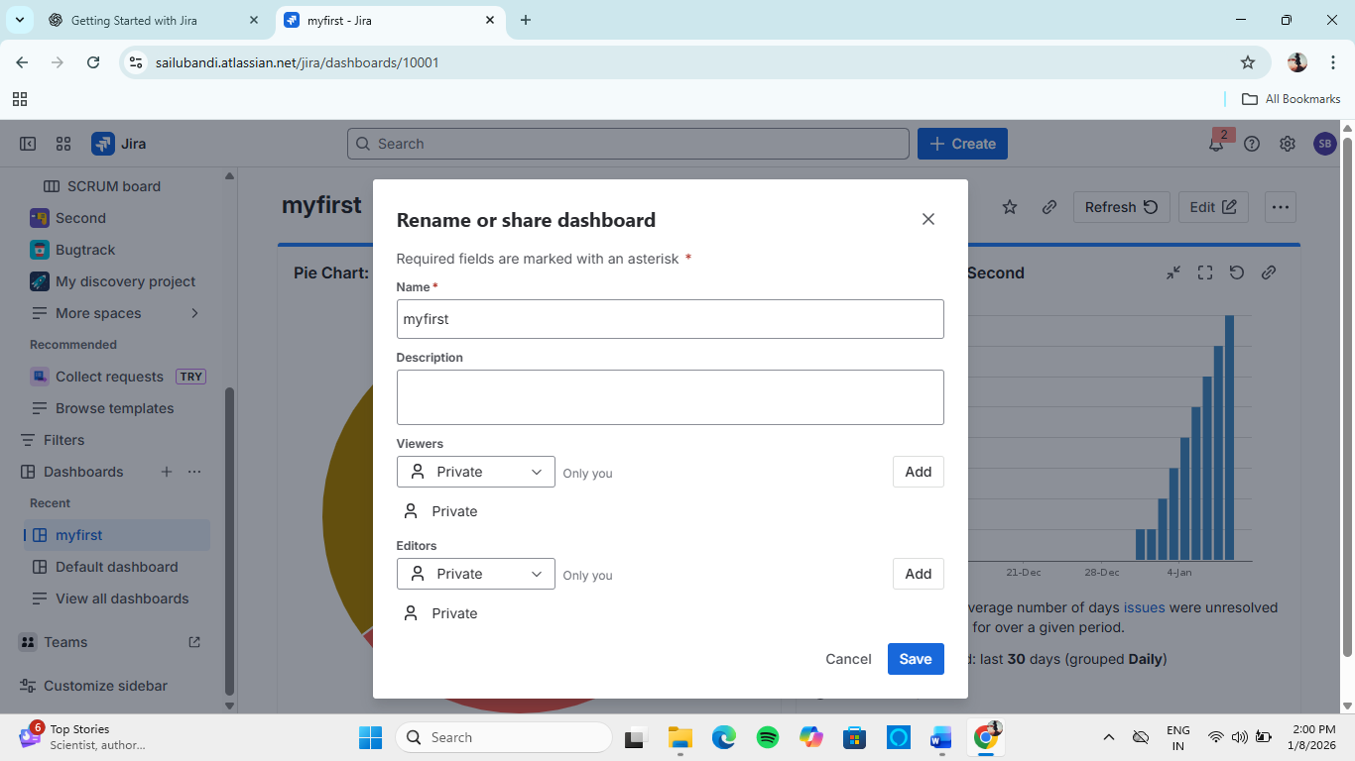

3.2 Cloning Dashboards
Cloning allows reuse of dashboard layouts.
Steps
- Open dashboard
- Click More → Copy dashboard
- Rename
- Save
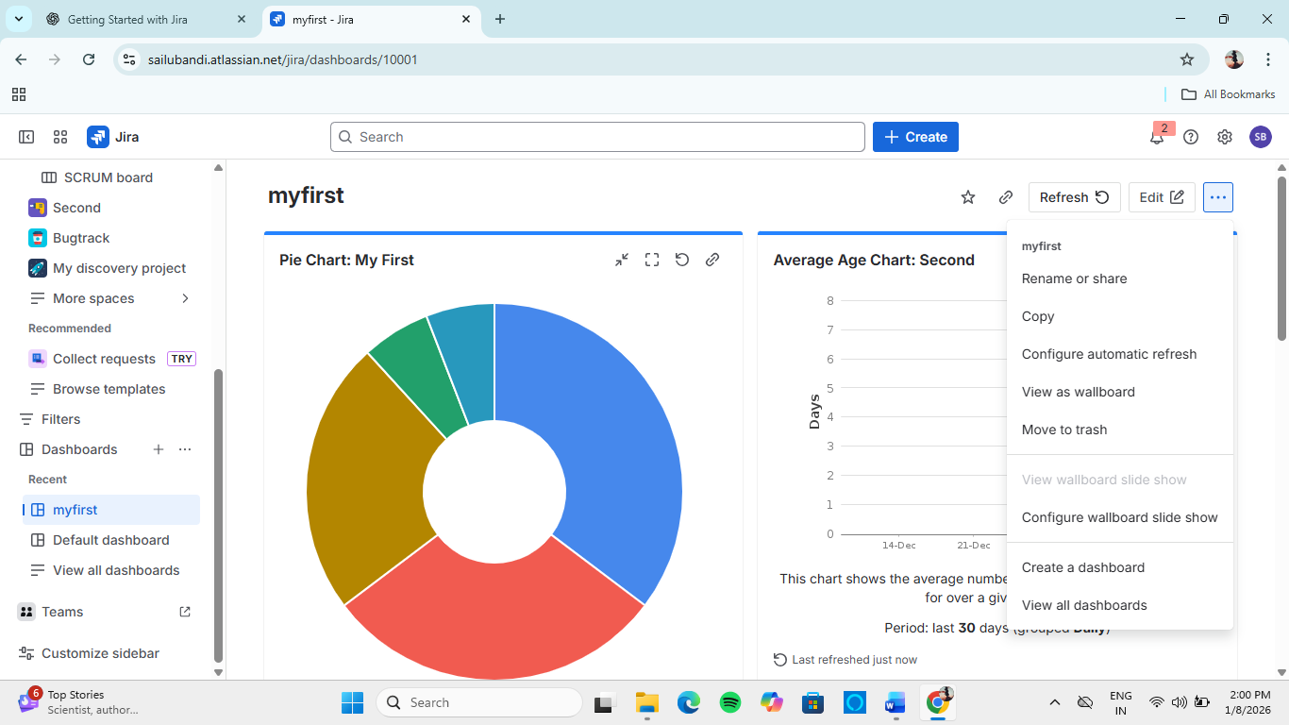

Use Cases
✔ Manager dashboards
✔ Team-specific views
✔ Stakeholder reporting

4. Scrum Reports in Jira
Scrum reports are used to measure sprint performance and team productivity.

4.1 Velocity Chart
Velocity shows how much work a team completes in each sprint.
Purpose:
- Forecast future sprints
- Measure team capacity
Healthy Velocity:
- Stable and consistent

Hands-On: View Velocity Chart
- Open Scrum Project
- Go to Reports
- Select Velocity Chart
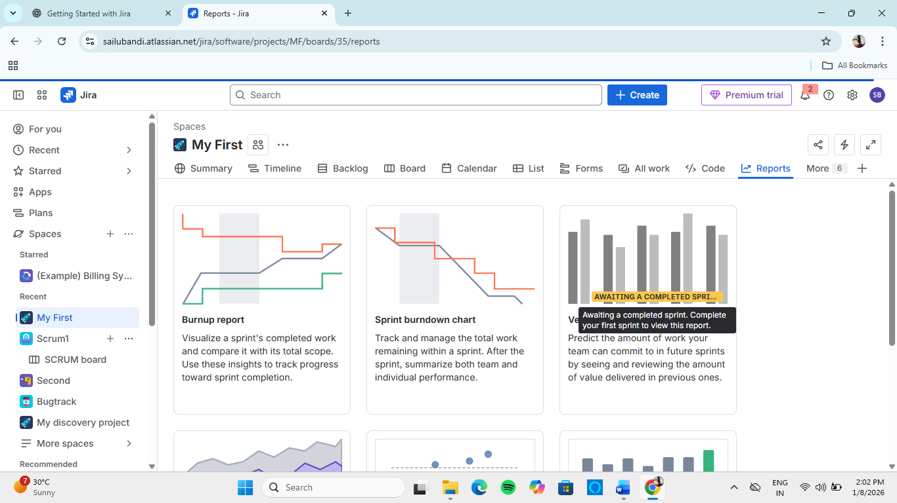

4.2 Burndown Chart
The Burndown Chart shows remaining work vs time in a sprint.
Purpose:
- Track sprint progress
- Identify delays early
Interpretation:
- Ideal line → planned progress
- Actual line above ideal → work behind schedule

Hands-On: View Burndown
- Open Active Sprint
- Click Reports → Burndown Chart
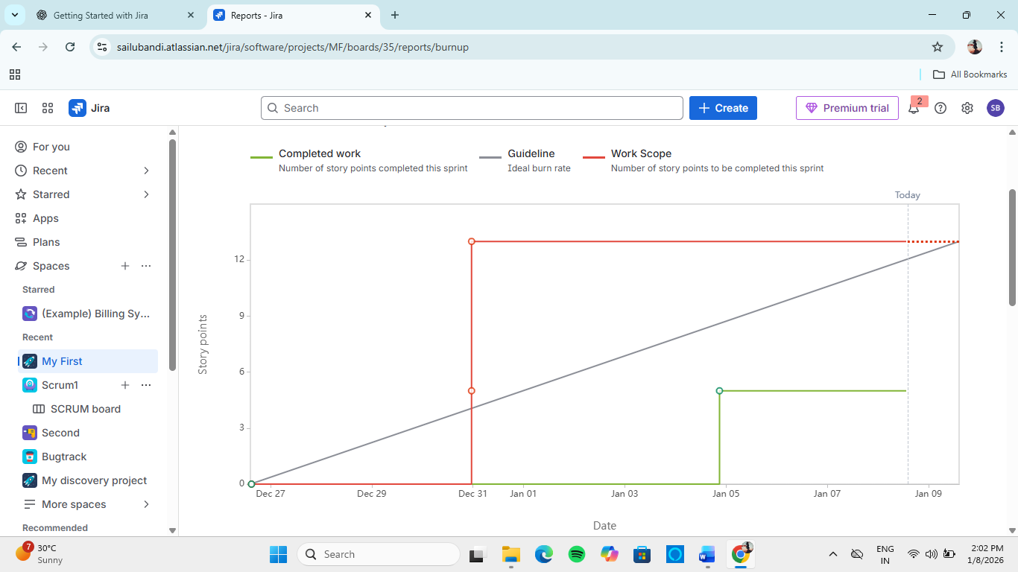

4.3 Sprint Report
The Sprint Report summarizes:
- Completed issues
- Incomplete issues
- Scope changes
Used for: Sprint review & retrospective

5. Kanban Reports in Jira
Kanban reports focus on flow efficiency and cycle time.

5.1 Control Chart
The Control Chart shows cycle time for issues.
Purpose:
- Measure delivery speed
- Identify inconsistencies
Lower & stable cycle time = Healthy flow

5.2 Cumulative Flow Diagram (CFD)
The CFD shows work-in-progress trends over time.
Purpose:
- Identify bottlenecks
- Analyze workflow stability

How to Read CFD
- Parallel bands → Stable workflow
- Expanding middle band → Bottleneck
- Steep Done line → High throughput

Hands-On: View CFD
- Open Kanban Project
- Go to Reports
- Select Cumulative Flow Diagram
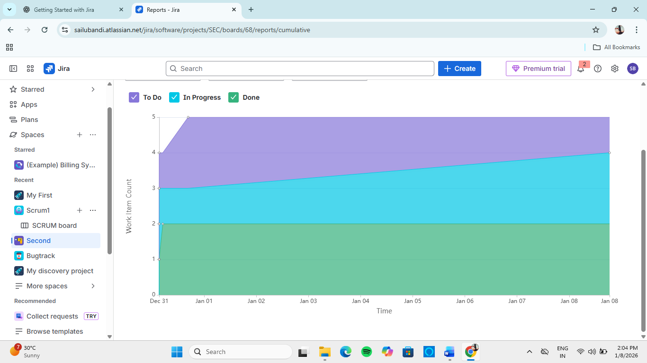

6. Best Practices for Dashboards & Reports
✔ Use saved filters consistently
✔ Keep dashboards role-specific
✔ Review reports regularly (weekly)
✔ Use Scrum reports for planning
✔ Use Kanban reports for optimization

7. Learning Outcomes
After this module, the learner can:
- Create and manage Jira dashboards
- Use gadgets for real-time insights
- Share and clone dashboards
- Interpret Scrum and Kanban reports
- Track team performance effectively

